**SMARTPHARASE INSTRUCTIONS AND SMARTPHRASE TEMPLATE**

A Smartphrase is how you identify your specific organization in Epic when preparing to make an Epic Fax referral to QuitlineNC.

To create your Smartphrase, input the referring organization’s information into the first part of the form and save it in Epic.

You can create more than one Smartphrase to identify various locations (ex: .QLNCWINSTON Or .QLNCTRIANGLE), so those doing referrals will use the right one for the location with the correct Fax number every time. You can choose whether to create your own personal Smartphrase with your specific provider information, (like your name and phone number, in addition to the clinic info) or share one Smartphrase across the organization or location, and fill in the individual provider information as you go.

The second part of the form, information about the person being referred, is designed to automatically pull information from the patient’s chart into the note, or offer dropdown lists that you can select from to make filling it out quick and easy. That is why, for example, it says: @NAME@, this shortcut will automatically pull in the patient’s name from their chart every time you use it. If for some reason these do not work in your version of Epic, talk with your IT support to modify them appropriately.

**TEMPLATE:**

**QUITLINE NC REFERRAL:**

**Referring Organization Information:**

Organization: County: Zip code:

In order to receive a participant’s Outcome Report, you must be a HIPAA-Covered Entity

_____ Yes, we are a HIPAA-Covered Entity

_____ Yes, I would like to receive an Outcome Report

Provider: Fax: Phone:

**Person being referred to QuitlineNC:**

Name: @NAME@ DOB: @DOB@

Address:

@ADD@

Gender: @SEX@ Pregnant: {YES / NO:22418}

Contact Information:

@PTPHONE@

Language preference: {Languages:200004::"English"}

_YES_ I am ready to quit tobacco use within the next 30 days or have recently quit. I request QuitlineNC to contact me to help me with my quit plan.

____ I DO NOT give permission to QuitlineNC to leave a message when contacting me.

Signature: Patient gave verbal permission to provider Date: @TD@

**Check the BEST time for QuitlineNC to call:**

- 9am - 12pm

- 12pm - 3pm

- 3pm - 6pm

- 6pm - 9pm

- 9pm - 12am

NOTE: QuitlineNC is open 24/7, but call attempts to participants are only made until midnight. Calls made over the weekend may be made at times outside of the 3-hour time frame selection.

Confidentiality Notice: This facsimile contains confidential information. If you have received this facsimile in error, please notify the sender immediately by telephone and confidentially dispose of the material. Do not review, disclose, copy, or distribute.

**INSTRUCTIONS FOR FAXING A QUITLINE REFERRAL USING EPIC**

**Clinical Support Staff**

1. Open an encounter (telephone or other)
2. In Documentation or Progress Note, enter smart phrase name
3. Fax referral form will populate patient information, **you need to specify provider’s name, if the phone number they want the QuitlineNC to call is different than the one in their chart.**
4. Indicate language preference and “Yes” to being ready to quit in next 30 days. **Highlight best time to call.** (your IT folks may be able to create a drop down list that can be inserted into the smartphrase, with the choices for times and one time can be selected)

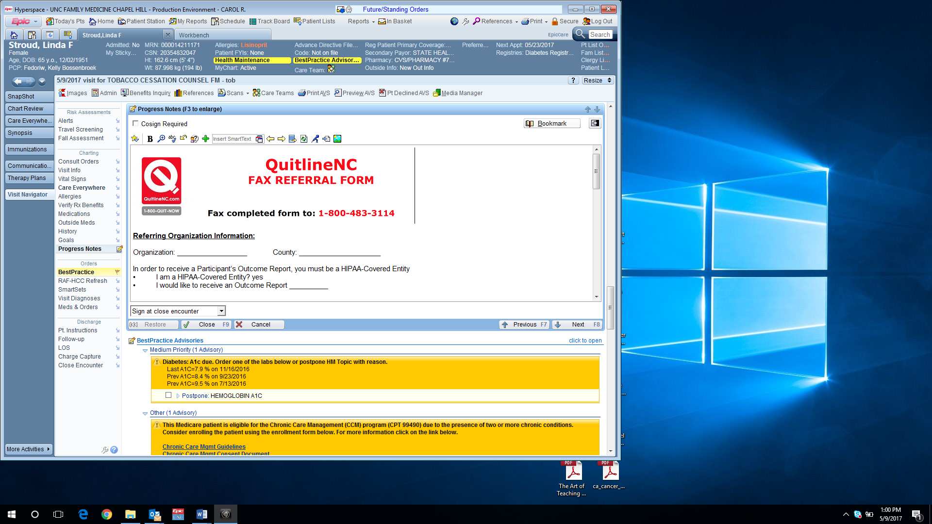

1. Close the encounter.
2. In Chart Review, highlight encounter and choose Route

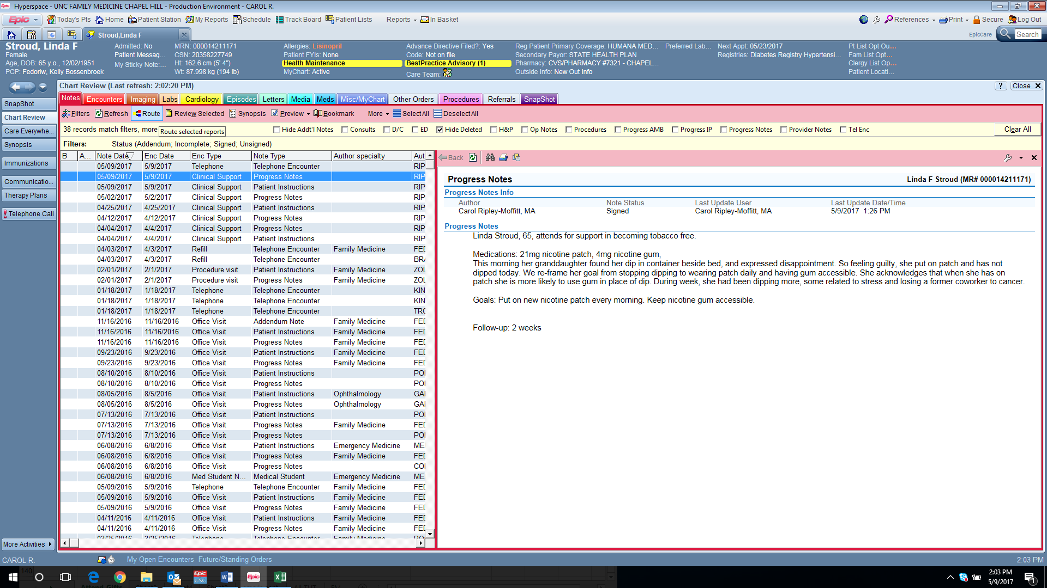

1. Choose ‘Other” and enter QUITLINE and the fax number 800-483-3114

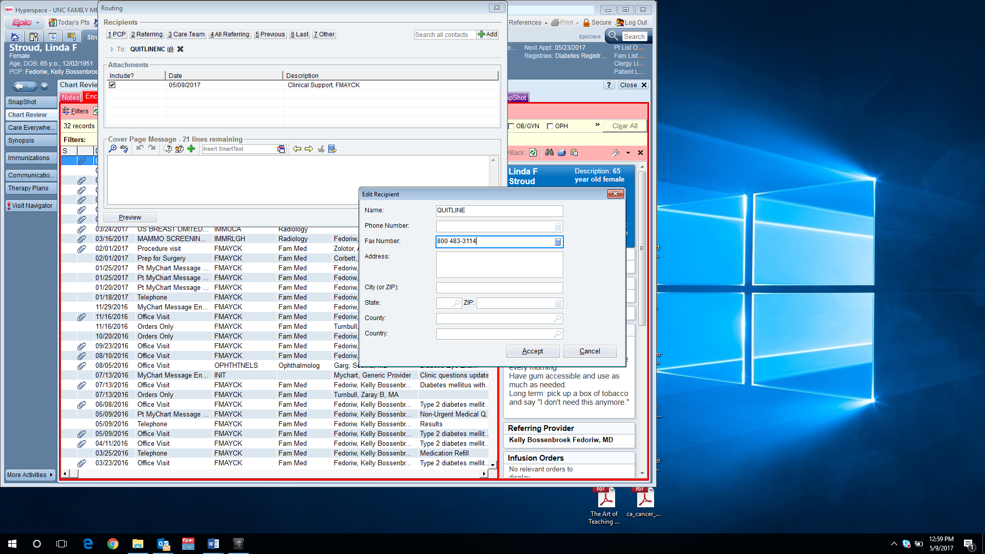 

1. Accept and send.

